Sandwich Meals
Served with a Side and Fountain Drink, Water or PBR
Chopped Brisket - $17
Pulled Pork - $16
Smoked Sausage Link - $16
Peppered Turkey Breast - $16
Burger Meals
Served with a Side and Fountain Drink, Water or PBR
1/3 Pound Angus Burger with American Cheese*-$15
Double 1/3 Pound Angus Burger with American*-$18
BBQ Burger- Burger topped with BBQ Meat Choice*-$20

Fish and Chips Meal $16
With Fountain Drink, Water or PBR
Beer Battered Fish, Fries, and Slaw

Chicken Meals
Served with a fountain Drink, Water or PBR
4 Breaded Chicken Tenders and Fries $15
Crispy Chicken Sandwich and Fries $15

Mac and Cheese Bowls
Served with a Fountain Soda, Water or PBR
Porky Butt Mac - $15
Beef Moola Mac - $16
Sausage Mac - $15
Veggie Nuggets Mac - $16

Kids Plates (12 and under)
Served with a Small Fry and a Soda, Juice or Milk
Kids Burger - $13
Crispy Chicken Tenders - $12
Mac and Cheese - $12

Sides
Seasoned Fries $6
Mac and Cheese $6
Mayo Coleslaw $5
Side Garden Salad $5
BBQ Beans $5

Large Garden Salad $12
With Fountain Drink, Water or PBR
Garden Salad – Chopped Lettuce, Shredded Carrot, Diced Red Pepper, Red Onion Slices and Cucumber Wedges
Salad Topped with Meat $16
With Fountain Drink, Water or PBR
Dressings: Blue Cheese, Ranch, Vinaigrette
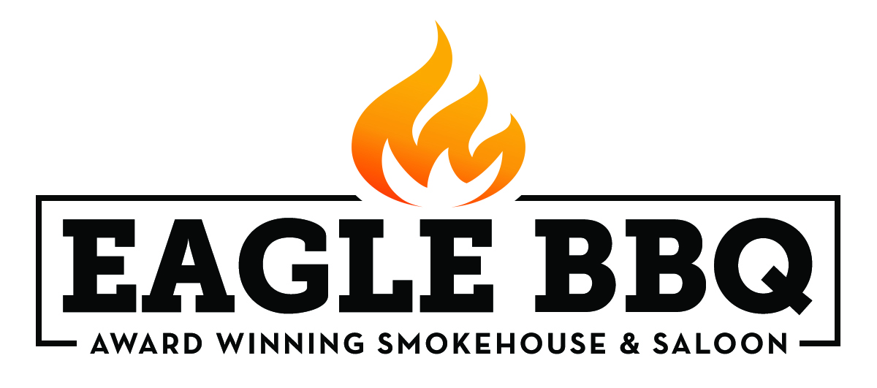
BBQ Platter Meals
½ lb. Meat per Serving, Served with a Choice of Side, Thick Cut White Bread, and a Fountain Drink, Water or PBR
One Meat $17
Two Different Meats $23
Three Different Meats $29
Meat Choices
Texas Style Sliced Brisket *add $1 per serving
Slow Smoked Pulled Pork
St. Louis Dry Rubbed Ribs
Peppered Turkey Breast
Smoked Sausage Link

Smoked Meat by the Pound
Brisket $19, Rack Ribs $30, ½ Rack Ribs $17, Pulled Pork $16, Sausage $16, Turkey $16
All ½ Pound Orders are $11 each

Chili
Served with cornbread
Brisket Red Chili $12

Beverages
Fountain Soda $4
Gatorade Bottle $4
Aquafina Bottled Water $2.50

Beers
16 oz. Draft PBR $3
16 oz. Draft Craft Beer $4-$5
Canned Beer $4-$6

Sweets
Cookie $2
Brownie $3
Pie $3

For General Information or Catering Inquiries Call 970-367-5007
See our Website www.whiskeyandbbq.com
Or Email: Theeaglebbq@gmail.com
Prices do not include tax
Not all items are available at all times, we do sell out.
*Consuming raw or undercooked food may increase risk of foodborne illness

